1. Assume that there are 3 page frames which are initially empty. If the page reference string is 1, 2, 3, 4, 2, 1, 5, 3, 2, 4, 6, the number of page faults using the optimal replacement policy is__________.

**(A)** 5

**(B)** 6

**(C)** 7

**(D)** 8

**Answer (C)**

**Explanation :**

In optimal page replacement replacement policy, we replace the place which is not used for longest duration in future.

Given three page frames.

Reference string is **1, 2, 3, 4, 2, 1, 5, 3, 2, 4, 6**

Initially, there are three page faults and entries are

1 2 3

Page 4 causes a page fault and replaces 3 (3 is the longest

distant in future), entries become

1 2 4

Total page faults = 3+1 = 4

Pages 2 and 1 don\'t cause any fault.

5 causes a page fault and replaces 1, entries become

5 2 4

Total page faults = 4 + 1 = 5

3 causes a page fault and replaces 5, entries become

3 2 4

Total page faults = 5 + 1 = 6

3, 2 and 4 don\'t cause any page fault.

6 causes a page fault.

Total page faults = 6 + 1 = 7

**Problem 2**

A system uses 3 page frames for storing process pages in main memory. It uses the First in First out (FIFO) page replacement policy. Assume that all the page frames are initially empty. What is the total number of page faults  that will occur while processing the page reference string given below-

4 , 7, 6, 1, 7, 6, 1, 2, 7, 2

Also calculate the hit ratio and miss ratio.

Problem 3:

Given page reference string:

● 1,2,3,4,2,1,5,6,2,1,2,3,7,6,3,2,1,2,3,6

● Compare the number of page faults for LRU, FIFO and Optimal page replacement algorithm and what which approve offers minimum page faults.

### **Q. Consider a reference string: 4, 7, 6, 1, 7, 6, 1, 2, 7, 2. the number of frames in the memory is 3. Find out the number of page faults respective to:**

1. Optimal Page Replacement Algorithm
2. FIFO Page Replacement Algorithm
3. LRU Page Replacement Algorithm

## Optimal Page Replacement Algorithm

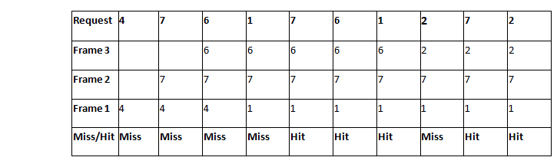

**Number of Page Faults in Optimal Page Replacement Algorithm = 5**

## LRU Page Replacement Algorithm

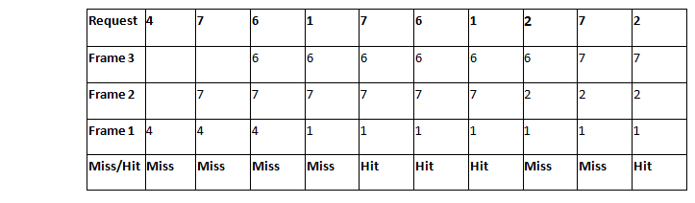

**Number of Page Faults in LRU = 6**

## FIFO Page Replacement Algorithm

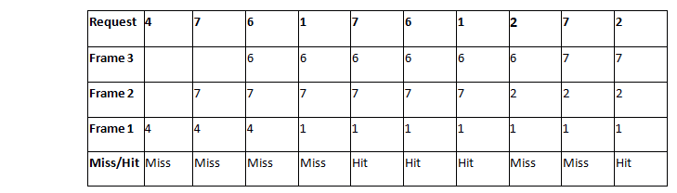

**Number of Page Faults in FIFO = 6**

**PROBLEM 5**

Consider the reference string 6, 1, 1, 2, 0, 3, 4, 6, 0, 2, 1, 2, 1, 2, 0, 3, 2, 1, 2, 0 for a memory with three frames and calculate number of page faults by using FIFO (First In First Out) Page replacement algorithms.qqqqqqqqqqqqq

+

**Points to Remember**

Page Not Found - - - > Page Fault

Page Found - - - > Page Hit

Reference String:

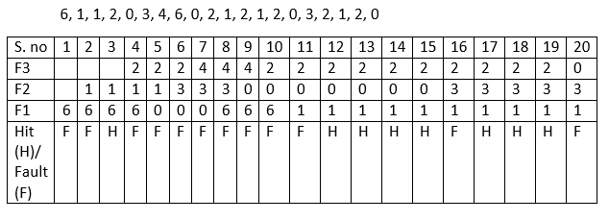

Number of Page Hits = 8

Number of Page Faults = 12

The Ratio of Page Hit to the Page Fault = 8 : 12 - - - > 2 : 3 - - - > 0.66

The Page Hit Percentage = 8 *100 / 20 = 40%

The Page Fault Percentage = 100 - Page Hit Percentage = 100 - 40 = 60%

**Explanation**

First, fill the frames with the initial pages. Then, after the frames are filled we need to create a space in the frames for the new page to occupy. So, with the help of First in First Out Page Replacement Algorithm we remove the frame which contains the page is older among the pages. By removing the older page we give access for the new frame to occupy the empty space created by the First in First out Page Replacement Algorithm.